Java Programming Assignment 1

Instructions:

1. Print 'Hello' and Your Name

Write a Java program to print 'Hello' on the screen and then print your name on a separate

line.

Expected Output:

Hello

Alexandra Abramov  
**Input:**

class Hello{

public static void main(String args[]){

System.out.println("Hello");

System.out.println("Alexandra Abramov");

}

} **Output:**

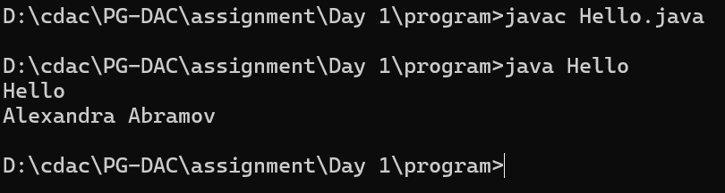

**Flowchart:**

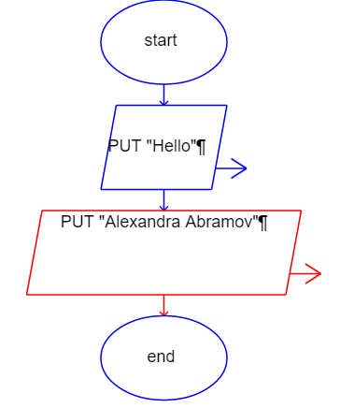

2. Sum of Two Numbers

Write a Java program to print the sum of two numbers.

Test Data: 74 + 36

Expected Output:

110

**Input:**

class Add{

public static void main(String args[]){

int sum = 74 + 36;

System.out.println("Sum of two number is : " + sum);

}

} **Output:**

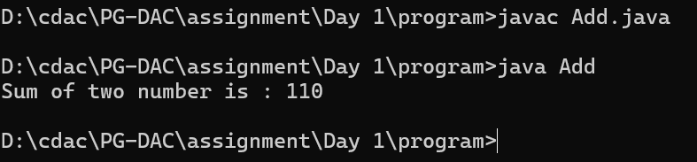

**Flowchart:**

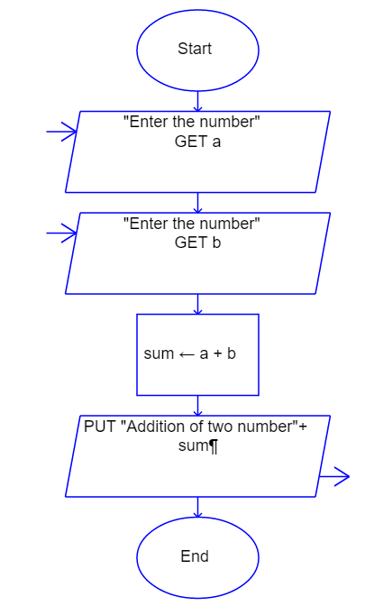

3. Divide Two Numbers

Write a Java program to divide two numbers and print the result on the screen.

Test Data: 50 / 3

Expected Output:

16

**Input:**

class Divide{

public static void main(String args[]){

int div = 50/3;

System.out.println("50/3= " + div);

}

} **Output:**

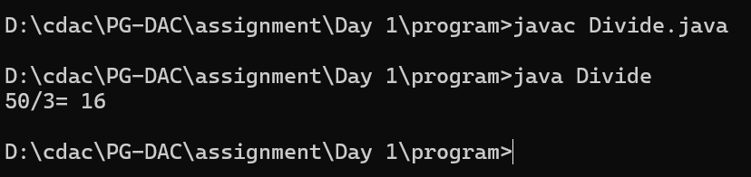

**Flowchart:**

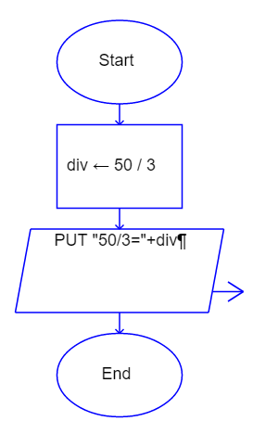

4. Perform Arithmetic Operations

Write a Java program to print the result of the following operations.

Test Data:

a. -5 + 8 * 6

b. (55 + 9) % 9

c. 20 + -3 * 5 / 8

d. 5 + 15 / 3 * 2 - 8 % 3

Expected Output:

43

1

19

13

**Input:**

class Arithmetic{

public static void main(String args[]){

int a,b,c,d;

a= -5 + 8 * 6;

b= (55 + 9) % 9;

c= 20 + -3 * 5 / 8;

d= 5 + 15 / 3 * 2 - 8 % 3;

System.out.println("-5 + 8 * 6= " + a);

System.out.println("(55 + 9) % 9= " + b);

System.out.println("20 + -3 * 5 / 8= " + c);

System.out.println("5 + 15 / 3 * 2 - 8 % 3= " + d);

}

} **Output:**

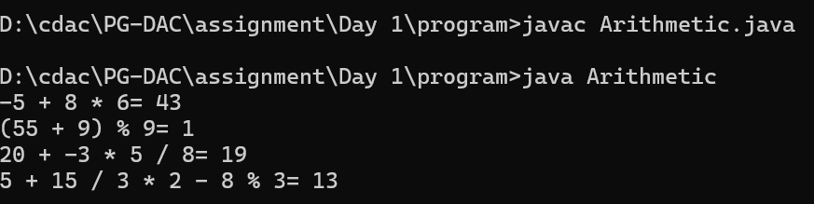

**Flowchart:**

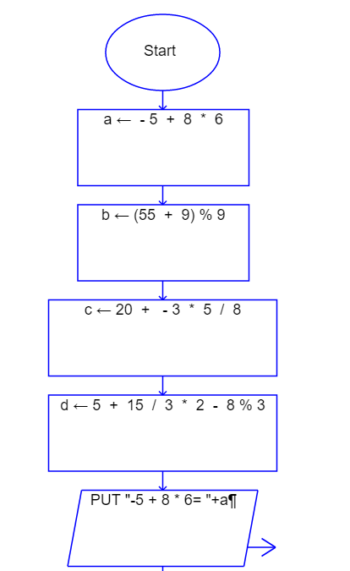

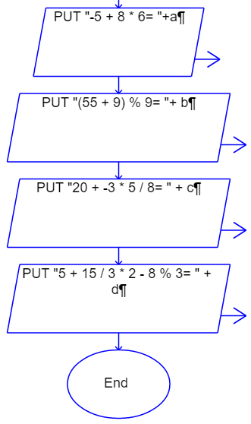

5. Multiply Two Numbers

Write a Java program that takes two numbers as input and displays the product of the two

numbers.

Test Data:

• Input first number: 25

• Input second number: 5

Expected Output:

25 x 5 = 125

**Input:**

import java.util.Scanner;

class Multiply{

public static void main(String args[]){

Scanner input = new Scanner(System.in);

int a,b,mult;

System.out.println("Enter two number");

a = input.nextInt();

b = input.nextInt();

mult= a*b;

System.out.println("25 x 5 = "+ mult);

}

} **Output:**

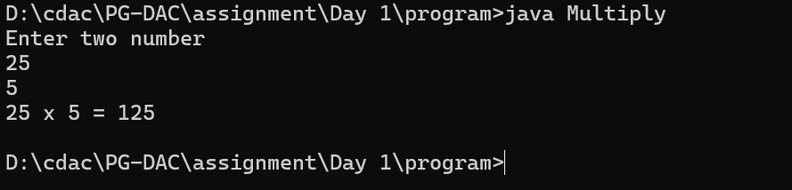

**Flowchart:**

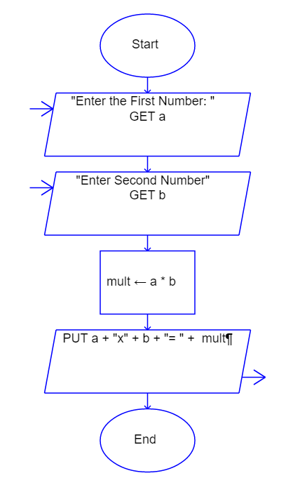

6. Basic Arithmetic Operations

Write a Java program to print the sum, multiplication, subtraction, division, and remainder of two numbers.

Test Data:

• Input first number: 125

• Input second number: 24

Expected Output:

125 + 24 = 149

125 - 24 = 101

125 x 24 = 3000

125 / 24 = 5

125 mod 24 = 5

**Input:**

import java.util.Scanner;

class Basic{

public static void main(String args[]){

Scanner input = new Scanner(System.in);

int a,b,add,sub,mult,div,rem;

System.out.println("Enter two number");

a = input.nextInt();

b = input.nextInt();

add=a+b;

sub=a-b;

mult= a*b;

div= a/b;

rem= a%b;

System.out.println(a+ " + " + b +"= "+ add);

System.out.println(a+ " - " + b +"= "+ sub);

System.out.println(a+ " x " + b +"= "+ mult);

System.out.println(a+ " / " + b +"= "+ div);

System.out.println(a+ " mod " + b +"= "+ rem);

}

} **Output:**

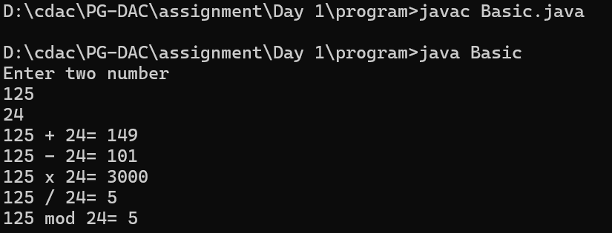

**Flowchart:**

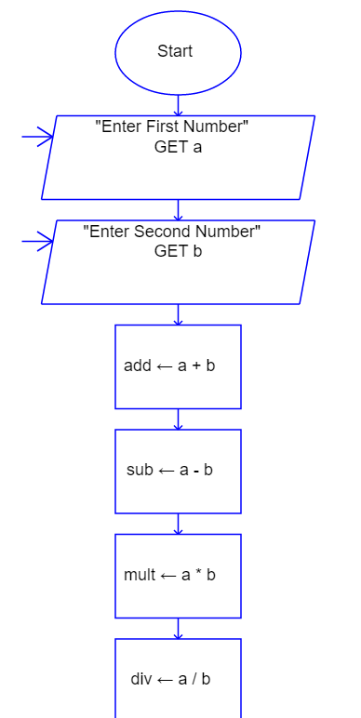

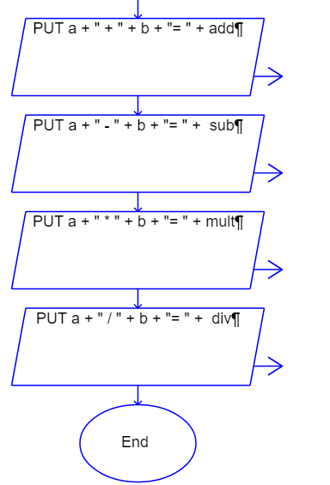

7. Multiplication Table

Write a Java program that takes a number as input and prints its multiplication table up to 10.

Test Data:

• Input a number: 8

Expected Output:

8 x 1 = 8

8 x 2 = 16

8 x 3 = 24

8 x 4 = 32

8 x 5 = 40

8 x 6 = 48

8 x 7 = 56

8 x 8 = 64

8 x 9 = 72

8 x 10 = 80

**Input:**

import java.util.Scanner;

class Table{

public static void main(String args[]){

Scanner input = new Scanner(System.in);

int a,mult;

System.out.println("Enter the number");

a = input.nextInt();

for(int i=1; i<=10; i++){

mult=a*i;

System.out.println(a+ " x " + i +"= "+ mult);

}

}

} **Output:**

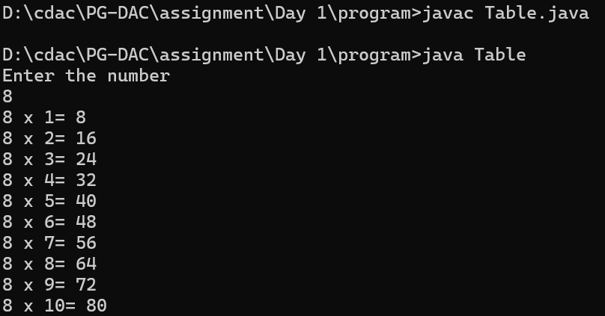

**Flowchart:**

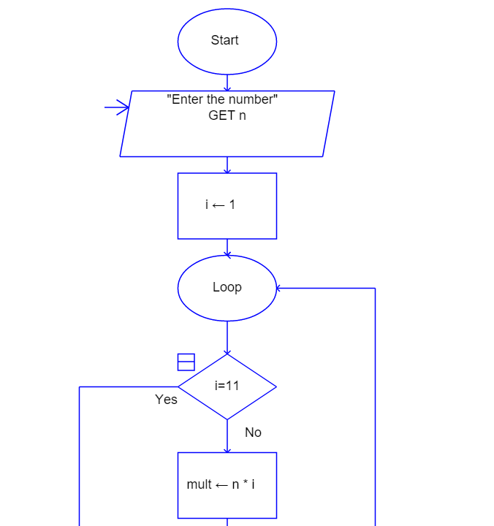

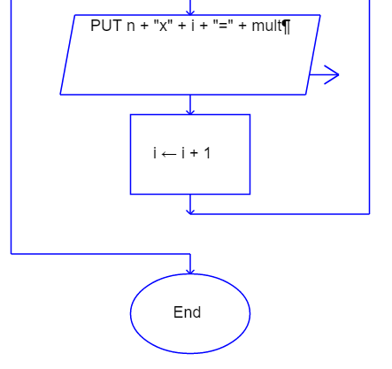

8. Swap Two Numbers

Write a Java program to swap the values of two variables without using a third variable.

Test Data:

• Input first number: 10

• Input second number: 20

Expected Output:

Before swapping:

First number: 10

Second number: 20

After swapping:

First number: 20

Second number: 10

**Input:**

import java.util.Scanner;

class Swap{

public static void main(String args[]) {

Scanner input = new Scanner(System.in);

System.out.println("Enter two numbers:");

int a = input.nextInt();

int b = input.nextInt();

System.out.println("Before swapping: a = " + a + ", b = " + b);

a = a + b;

b = a - b;

a = a - b;

System.out.println("After swapping: a = " + a + ", b = " + b);

}

} **Output:**

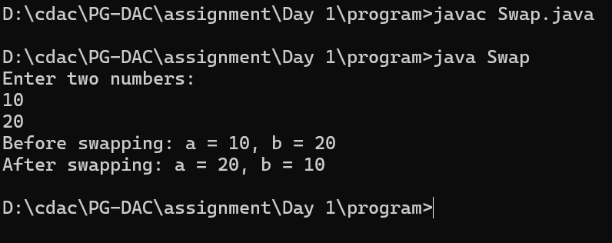

**Flowchart:**

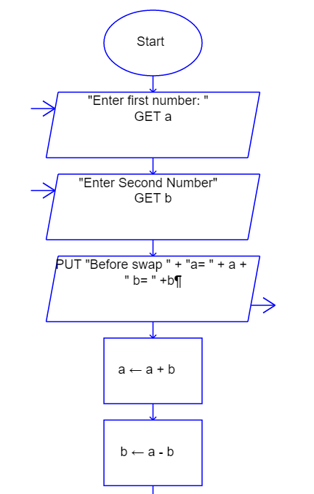

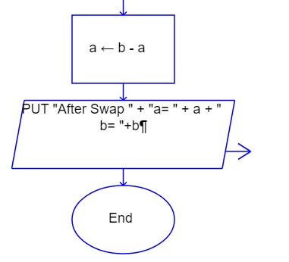

9. Calculate the Area of a Circle

Write a Java program that calculates the area of a circle.

Test Data:

• Input the radius: 7

Formula: Area = π * radius²

Expected Output:

Area of the circle: 153.93804

**Input:**

import java.util.Scanner;

class Area{

public static void main(String args[]){

Scanner input = new Scanner(System.in);

System.out.println("Enter the radius of the circle:");

int r = input.nextInt();

int area = 3.14*r*r;

System.out.println("Area of the circle: "+area);

}

} **Output:**

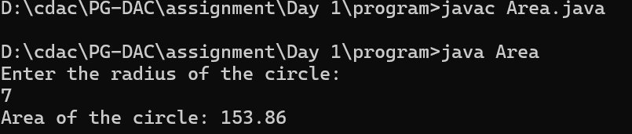

**Flowchart:**

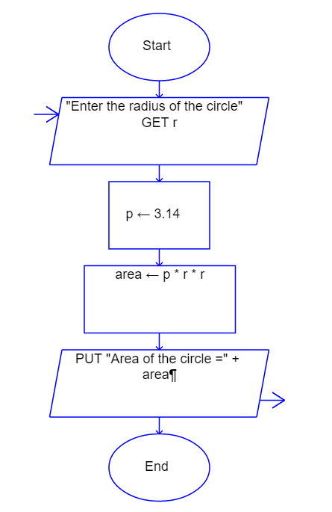

10. Check If a Number Is Even or Odd

Write a Java program that checks if a number is even or odd.

Test Data:

• Input a number: 15

Expected Output:

The number 15 is Odd.

**Input:**

import java.util.Scanner;

class Even{

public static void main(String args[]) {

Scanner input = new Scanner(System.in);

System.out.println("Enter the number :");

int n = input.nextInt();

if(n%2 == 0){

System.out.println(n+" is even number");

}

else{

System.out.println(n+" is odd number");

}

}

}

Output:

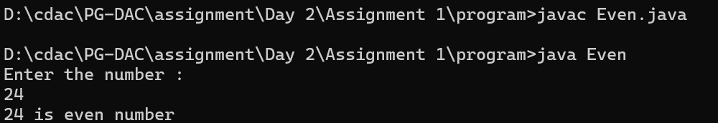

Flowchart:

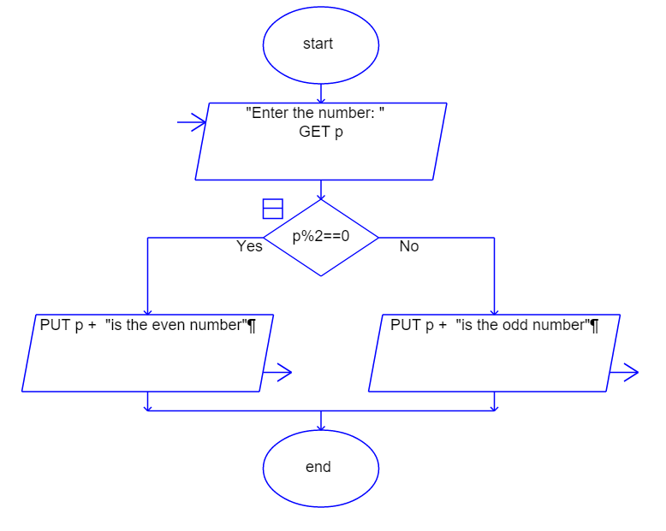

11. Find the Largest of Three Numbers

Write a Java program that takes three numbers as input and finds the largest of the three.

Test Data:

• Input first number: 12

• Input second number: 45

• Input third number: 22

Expected Output:

The largest number is 45.

**Input:**

import java.util.Scanner;

class Largest{

public static void main(String args[]) {

Scanner input = new Scanner(System.in);

System.out.println("Enter three numbers");

int a= input.nextInt();

int b= input.nextInt();

int c= input.nextInt();

if(a>b && b>c)

{

System.out.println(a+" is the greatest");

}

else if(a<b && b>c)

{

System.out.println(b+" is the greatest");

}

else

{

System.out.println(c+" is the greatest");

}

}

} **Output:**

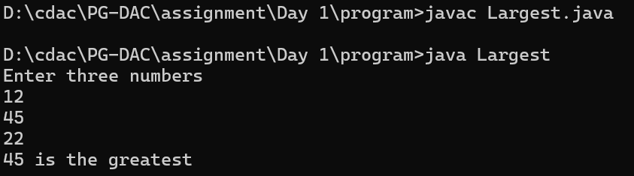

**Flowchart:**

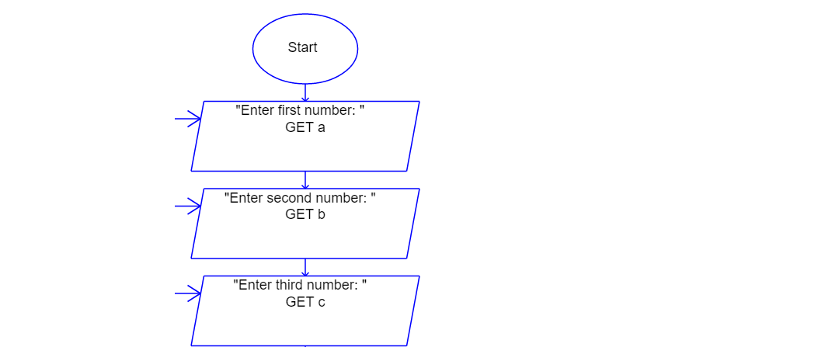 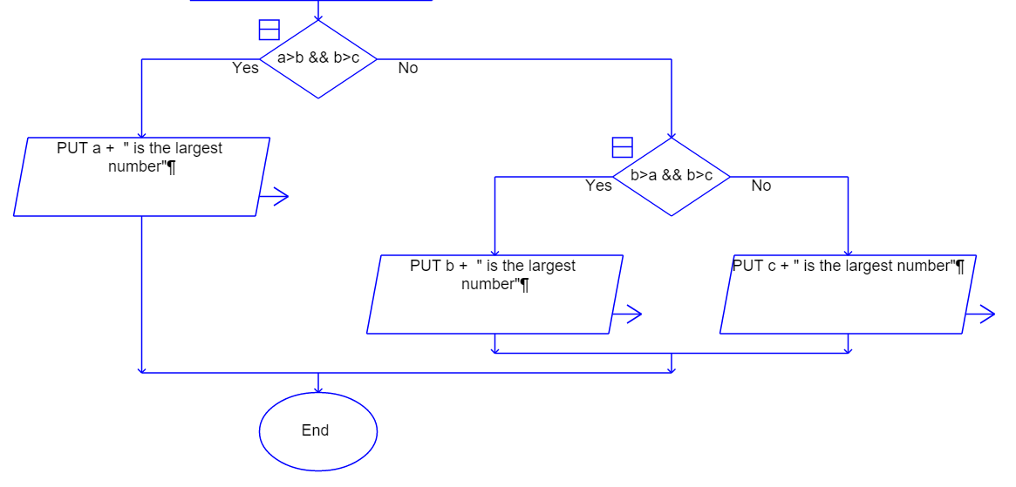

12. Reverse a Number

Write a Java program that takes a number as input and prints the reverse of that number.

Test Data:

• Input number: 12345

Expected Output:

The reverse of 12345 is 54321.

**Input:**

import java.util.Scanner;

public class Reverse{

public static void main(String[] args) {

Scanner scanner = new Scanner(System.in);

System.out.println("Enter the number: ");

int num = scanner.nextInt();

int reverse = 0;

while (num != 0) {

int digit = num % 10;

reverse = reverse * 10 + digit;

num /= 10;

}

System.out.println("The reverse of the number is " + reverse);

}

} **Output:**

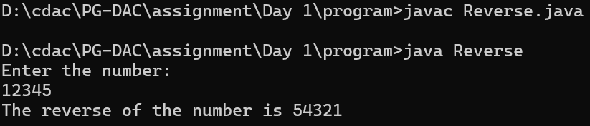

**Flowchart:**

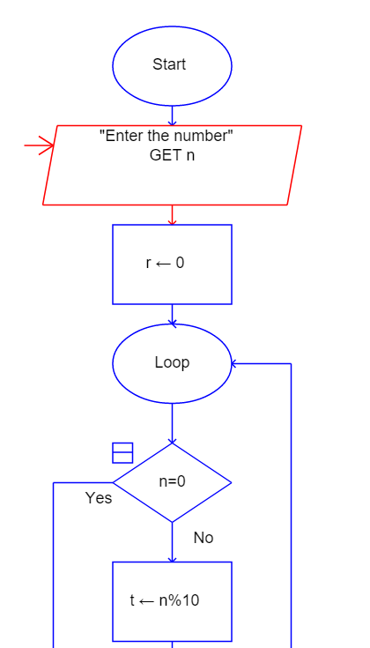

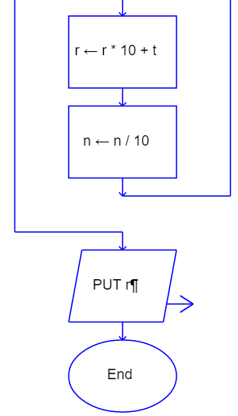

13. Calculate the Average of Three Numbers

Write a Java program to calculate the average of three numbers.

Test Data:

• Input first number: 20

• Input second number: 40

• Input third number: 60

Expected Output:

The average is: 40.0

**Input:**

import java.util.Scanner;

public class Average{

public static void main(String[] args) {

Scanner scanner = new Scanner(System.in);

System.out.println("Enter Three number: ");

int a = scanner.nextInt();

int b = scanner.nextInt();

int c = scanner.nextInt();

double avg=(a+b+c)/3;

System.out.println("The average of"+a+b+c+" number is " + avg);

}

} **Output:**

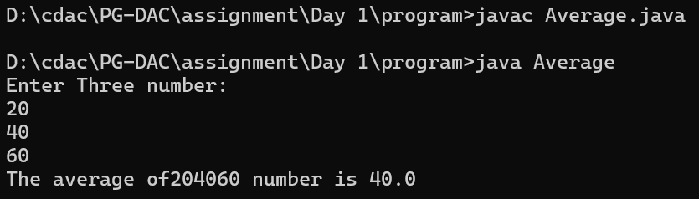

**Flowchart:**

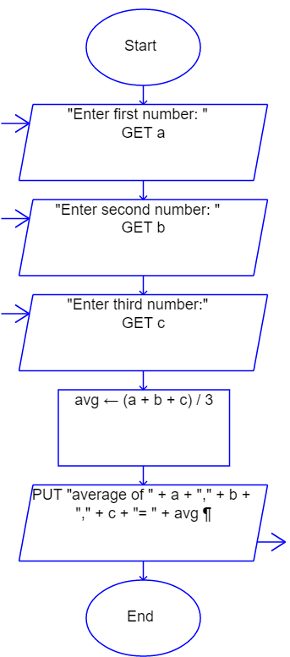

14. Print the Fibonacci Series

Write a Java program to print the Fibonacci series up to the 10th number.

Expected Output:

0 1 1 2 3 5 8 13 21 34

**Input:**

public class Fibonacci{

public static void main(String[] args) {

int f0 = 0;

int f1 = 1;

System.out.print(f0 +","+ f1);

for(int i=1;i<=8;i++){

int f=f0+f1;

System.out.print(","+ f);

f0=f1;

f1=f;

}

}

} **Output:**

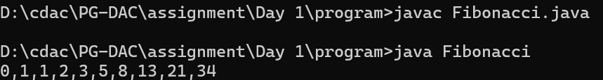

**Flowchart:**

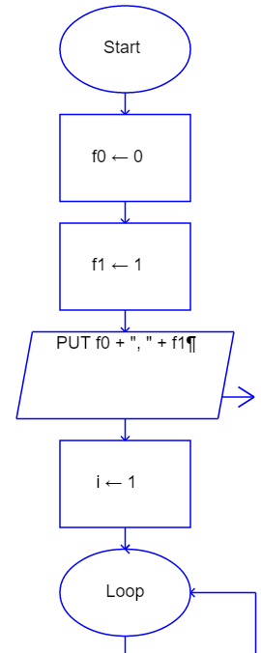

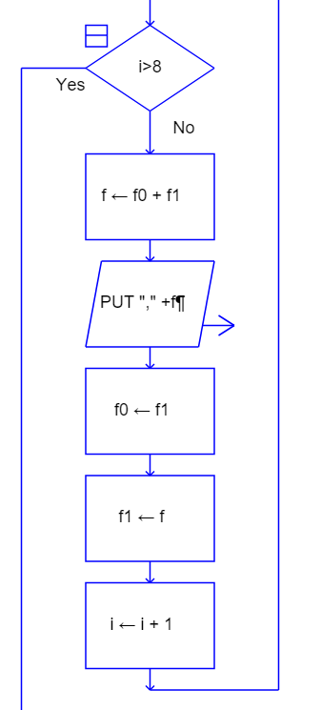

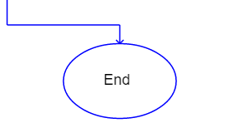

15. Find the Factorial of a Number

Write a Java program to find the factorial of a number.

Test Data:

• Input a number: 5

Expected Output:

Factorial of 5 is 120.

**Input:**import java.util.Scanner;

public class Factorial{

public static void main(String[] args) {

Scanner input = new Scanner(System.in);

System.out.println("Enter a number to find factorial: ");

int num = input.nextInt();

int fact=1;

for(int i=1;i<=num;i++)

{

fact=fact*i;

}

System.out.println(fact + " is the factorail of the number " + num);

}

} **Output:**

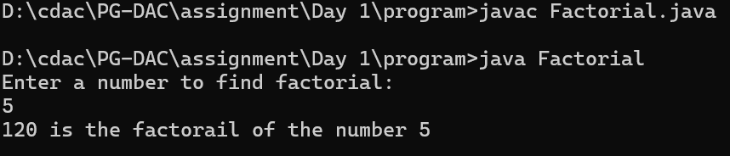

**Flowchart:**

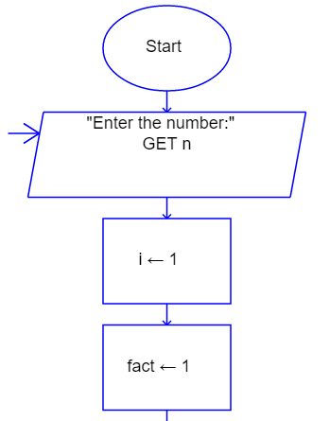

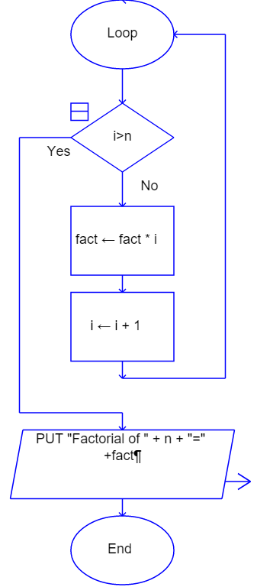

16. Check Whether a Number Is Prime

Write a Java program to check whether a number is prime or not.

Test Data:

• Input number: 17

Expected Output:

The number 17 is Prime.

**Input:**

import java.util.Scanner;

public class Prime{

public static void main(String[] args) {

Scanner input = new Scanner(System.in);

System.out.println("Enter the number");

int n = input.nextInt();

int c = 0;

if (n <= 1)

{

c = 1; }

else

{

for (int i = 2; i <= n / 2; i++)

{

if (n % i == 0)

{

c = 1;

}

}

}

if (c == 0) {

System.out.println(n + " is a prime number");

} else {

System.out.println(n + " is not a prime number");

}

}

} **Output:**

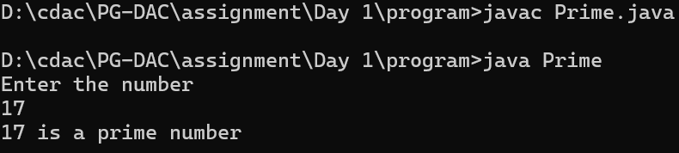

**Flowchart:**

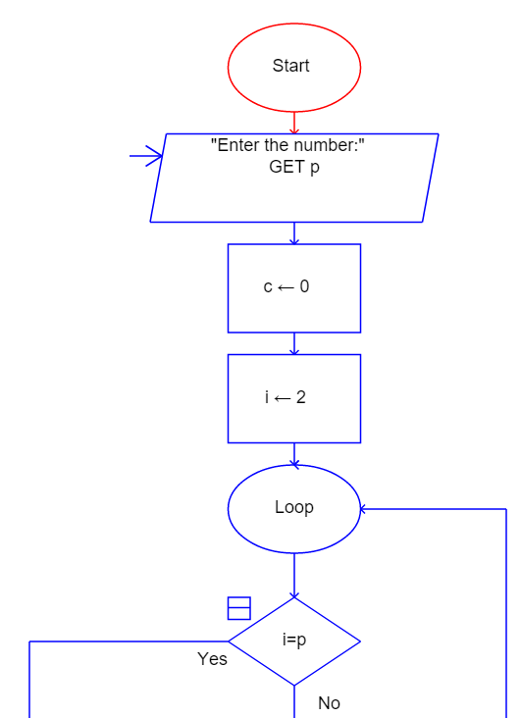

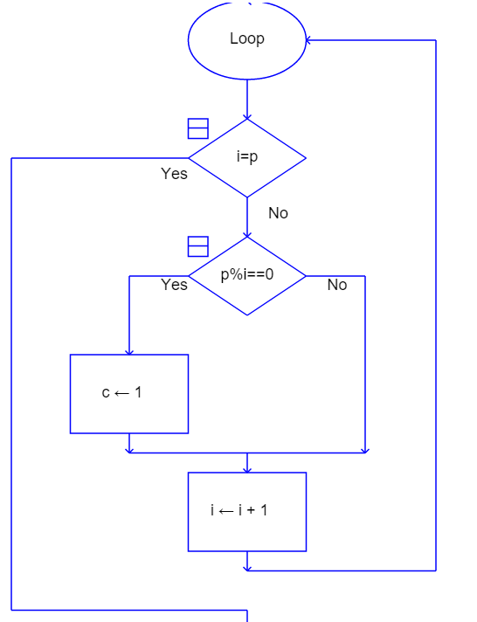

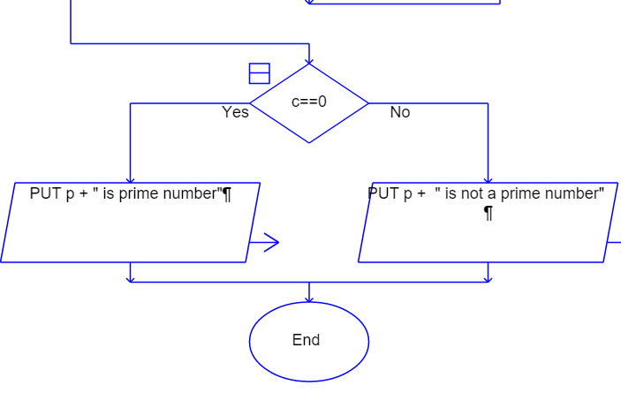

17. Print the First N Natural Numbers

Write a Java program to print the first N natural numbers, where N is provided by the user.

Test Data:

• Input a number: 6

Expected Output:

1 2 3 4 5 6

**Input:**

import java.util.Scanner;

public class NaturalNumbers {

public static void main(String[] args) {

Scanner input = new Scanner(System.in);

System.out.print("Enter a number: ");

int n = input.nextInt();

for (int i = 1; i <= n; i++)

{

System.out.print(i + " ");

}

}

} **Output:**

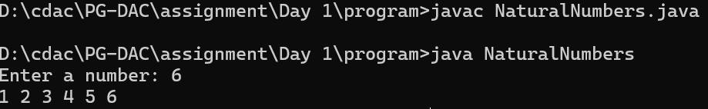

**Flowchart:**

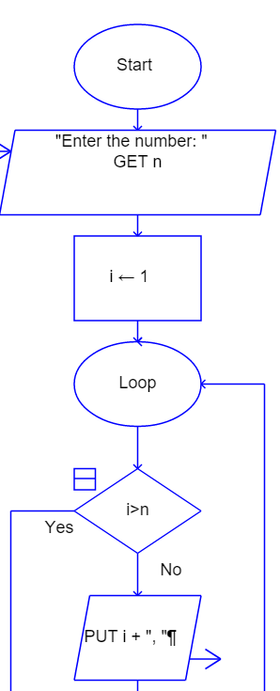

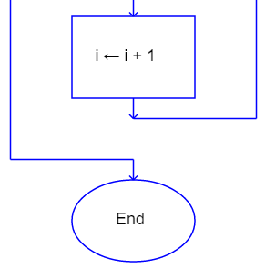

18. Convert Celsius to Fahrenheit

Write a Java program to convert a temperature from Celsius to Fahrenheit.

Test Data:

• Input temperature in Celsius: 25

Formula: Fahrenheit = (Celsius * 9/5) + 32

Expected Output:

25°C is equal to 77.0°F

**Input:**

import java.util.Scanner;

public class Temp{

public static void main(String[] args) {

Scanner input = new Scanner(System.in);

System.out.print("Enter the temperature in celsius: ");

int celsius = input.nextInt();

double fahrenheit=(celsius*9/5)+32;

System.out.print(celsius+ " C = "+ fahrenheit +"F");

}

} **Output:**

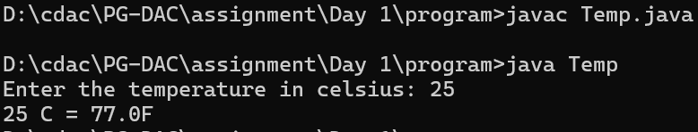

**Flowchart:**

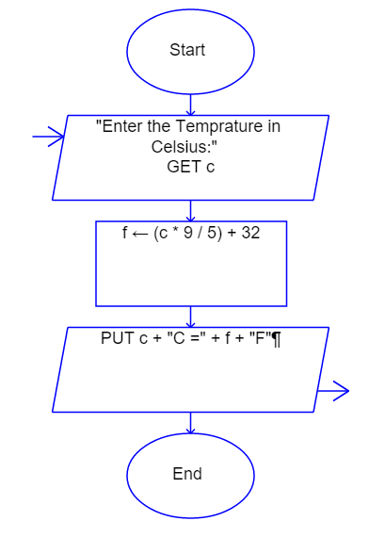

19. Calculate the Power of a Number

Write a Java program that calculates the power of a number. Take two numbers as input: the

base and the exponent, and compute the result of base raised to the power of exponent.

Test Data:

• Input base number: 3

• Input exponent number: 4

Expected Output:

3 raised to the power 4 is 81

**Input:**

import java.util.Scanner;

public class Power {

public static void main(String[] args) {

Scanner input = new Scanner(System.in);

System.out.print("Input base number: ");

int base = input.nextInt();

System.out.print("Input exponent number: ");

int exponent = input.nextInt();

int result = 1;

for (int i = 0; i < exponent; i++)

{

result *= base;

}

System.out.println(base + " raised to the power " + exponent + " is " + result);

}

} **Output:**

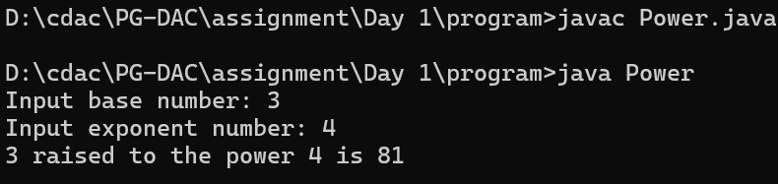

**Flowchart:**

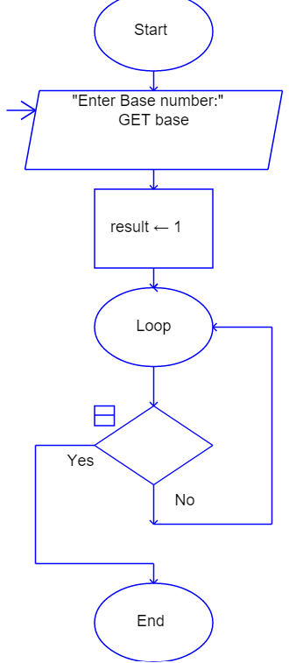

20. Count the Number of Digits in a Number

Write a Java program that counts the number of digits in a given number.

Test Data:

• Input number: 123456

Expected Output:

The number 123456 has 6 digits.

**Input:**

import java.util.Scanner;

public class Counter {

public static void main(String[] args) {

Scanner input = new Scanner(System.in);

System.out.print("Input number: ");

int number = input.nextInt();

int count = 0;

int temp = number;

while (number != 0) {

number /= 10;

count++;

}

System.out.println("The number " + temp + " has " + count + " digits");

}

} **Output:**

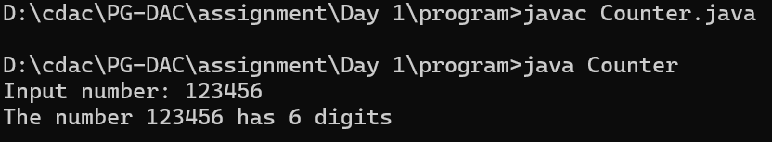

**Flowchart:**

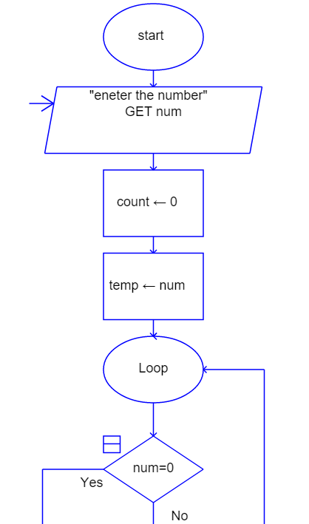

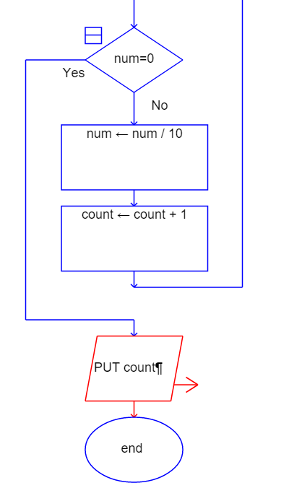

------X--------X--------X--------X--------X--------X--------